Batch: C2 Roll No.: 16010121200

Experiment 04

Grade: AA / AB / BB / BC / CC / CD /DD

Title: Tableau- Introduction to charts

Objective: To learn how to use various charts for visualizing preprocessed data in Tableau

Course Outcome:

CO1: Learn how to locate and download datasets, extract insights from that data and present their findings in a variety of different formats.

CO3: Apply data visualization best practices

Books/ Journals/ Websites referred:
https://www.kaggle.com/datasets/shekpaul/global-superstore

Resources used:
Tableau, Excel, Online Dataset

Theory (About various charts explored):

Charts enable you to visually compare multiple sets of data. Charts can help people better understand and remember information. Different types of charts require different measures and dimensions and provide different insights into the data.

Following points should be written by students

Different charts explored for data visualization:

Bar Chart

Line Chart

Pie Chart

Scatter Plot

Packed Bubble Chart

Donut Chart

Platform used by the student: Tableau

Working: Using tableau software

Screenshots of each chart output with variations explored on your dataset

Interpretation (what each chart signifies)

Bar Chart
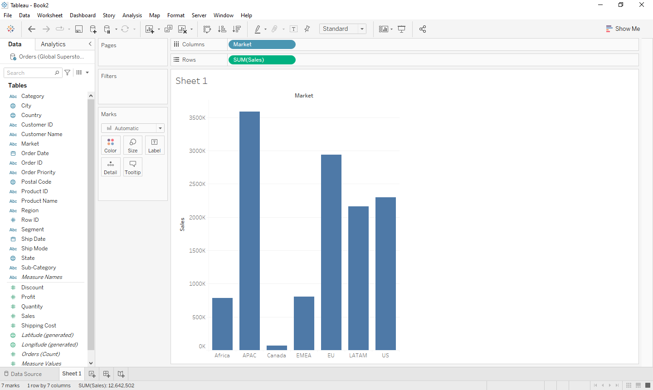
Sales vs Market. APAC market has the highest sales followed by EU market, while Canada market has the lowest sales. Africa and EMEA market have almost similar sales.
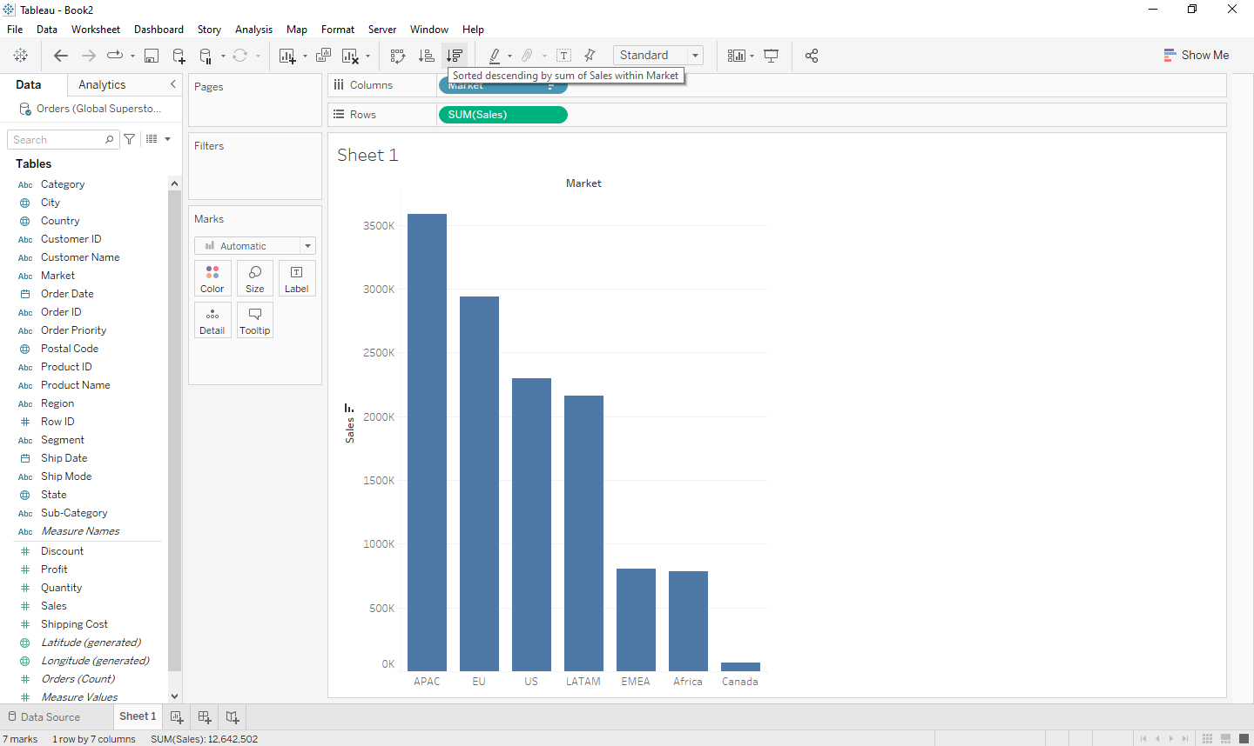
Sales vs Market sorted in descending order of Sales. EMEA market has slightly more amount of sales than Africa market.
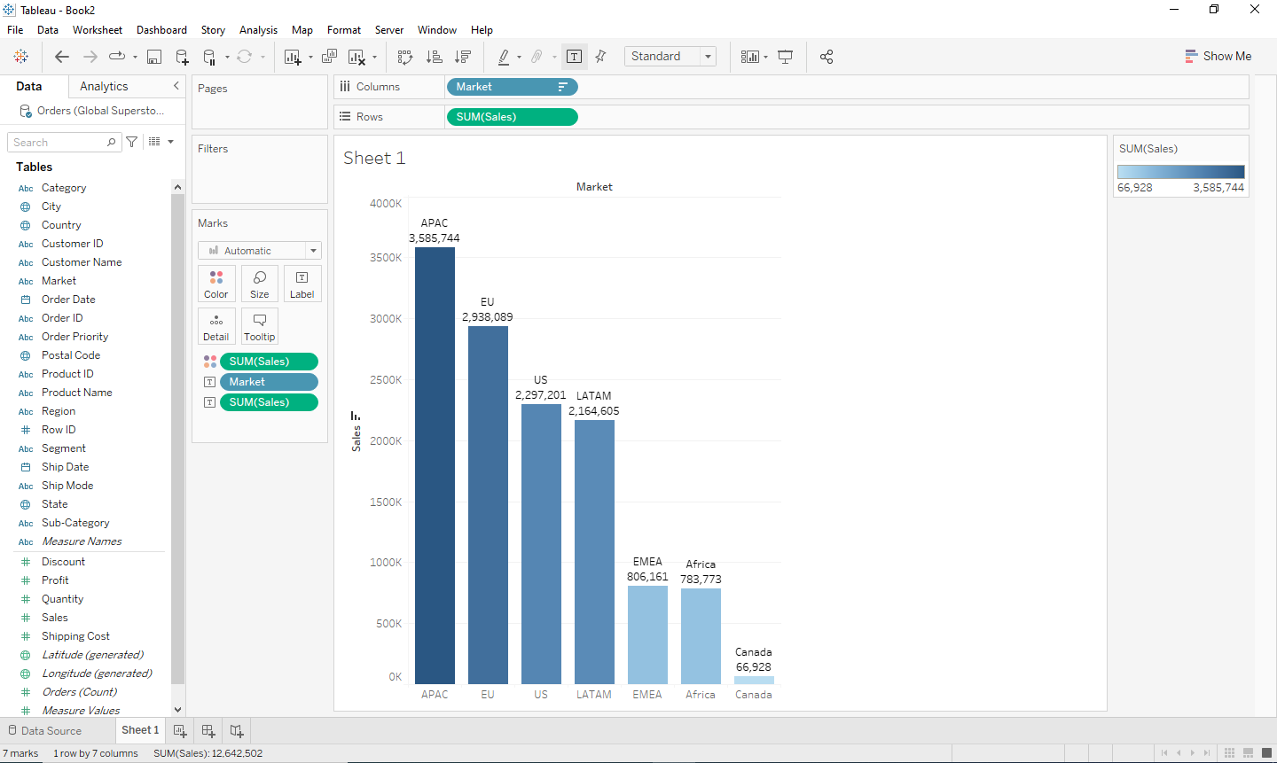
Sales vs Market sorted in descending order of Sales, coloured according to Sales and labelled with the Market name and Sales figure.

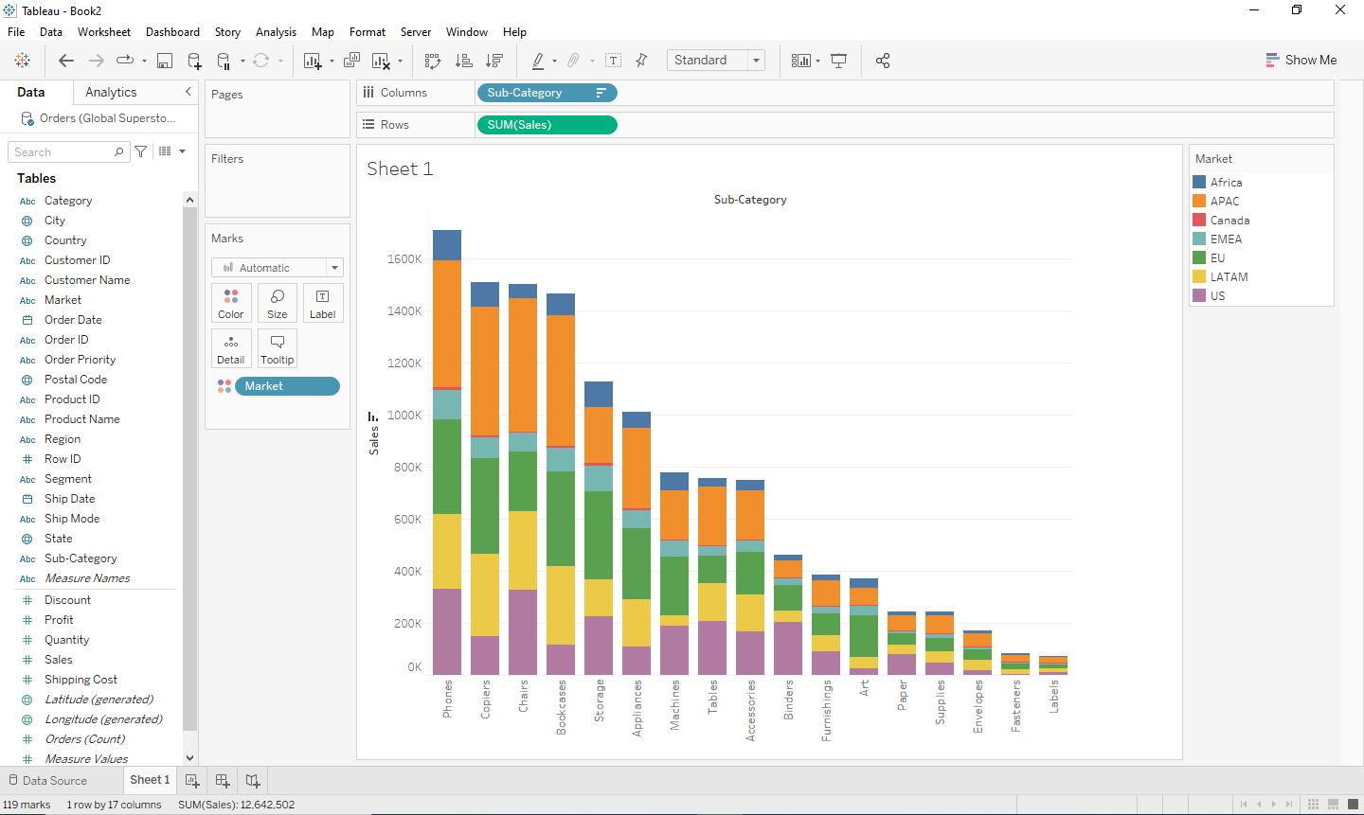
Sales vs Sub-categories, sorted in descending order of total sales, showing stacks of sales by different markets. Phones have the highest number of sales, while Labels sold the least.

Line Chart
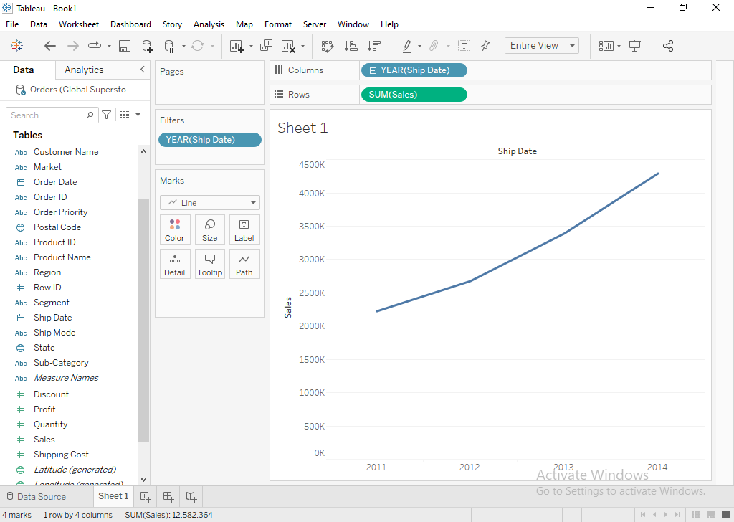
Represents total sales in years 2011-2014. The sales have been increasing over the given time period.
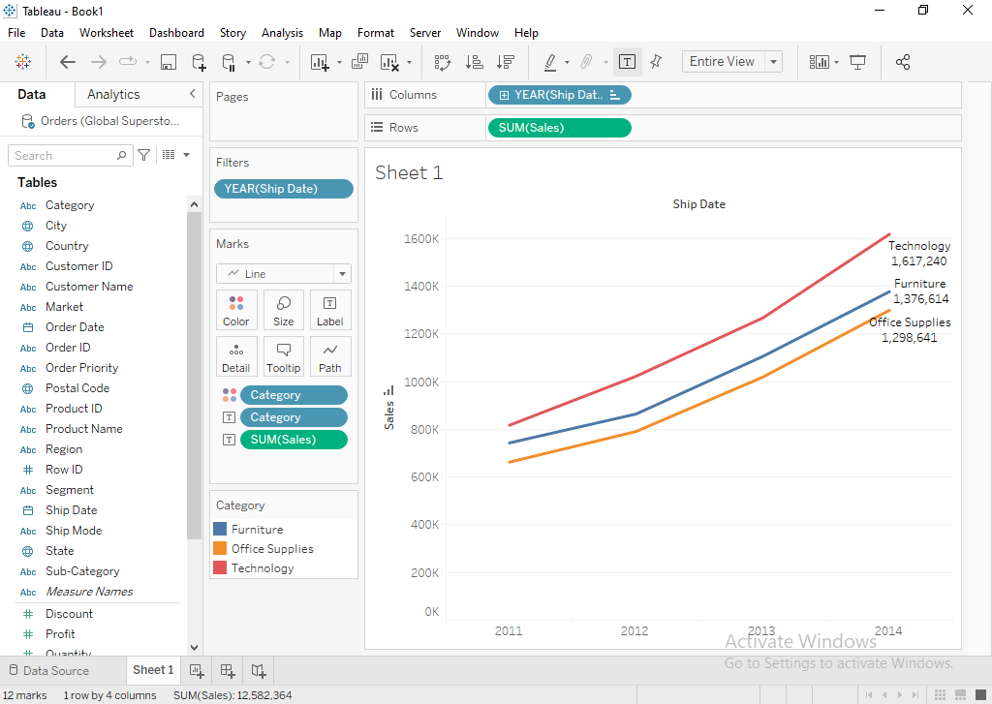
Represents sales in years 2011-2014 showing different categories in different colours. Labelled according to category and sales. Sales in Technology category have been the highest in all the years and are increasing over the years, while sales in office supplies have been the lowest in all the years but are increasing over the years.
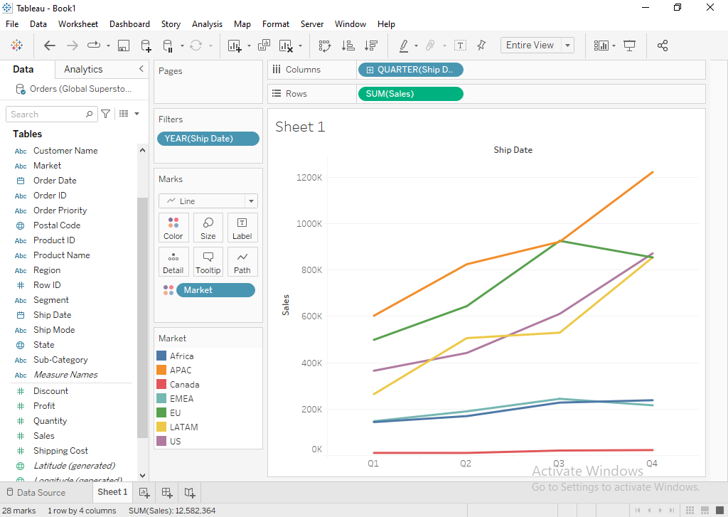
Represents sales of different markets in years 2011-2014 with ship year as a discrete variable.
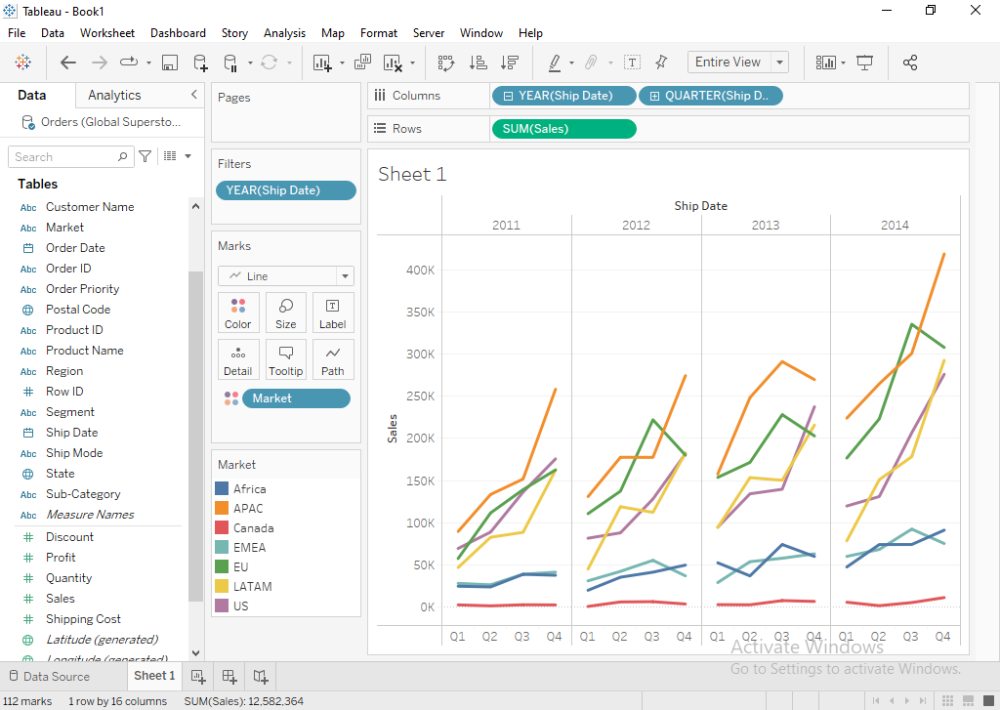
Represents sales of different markets in quarter years 2011-2014 with ship year as a discrete variable.
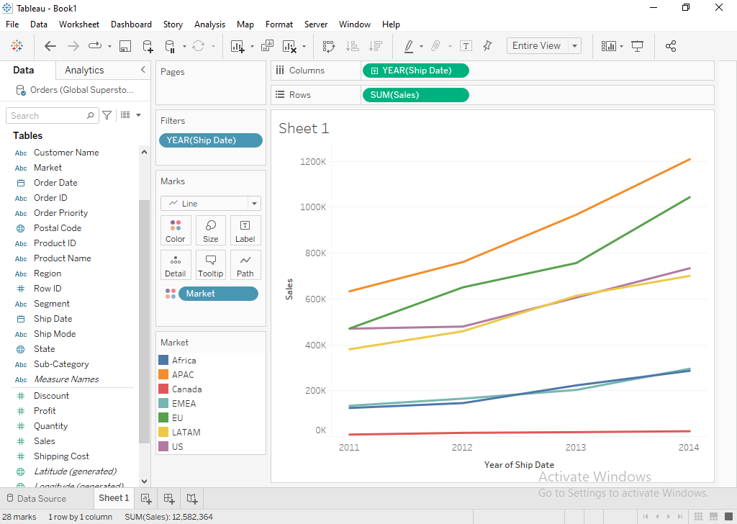
Represents sales of different markets in years 2011-2014 with ship year as a continuous variable.
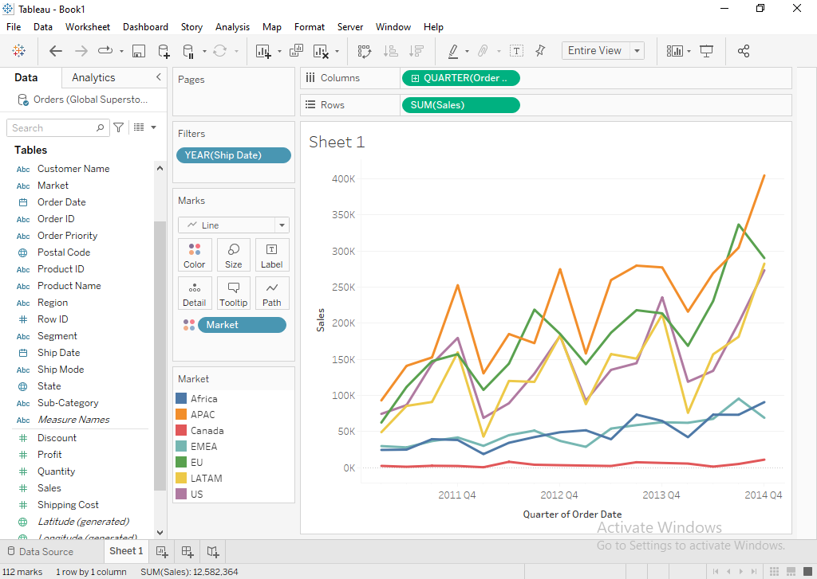
Represents sales of different markets in quarter years 2011-2014 with ship year as a continuous variable.
Pie Chart
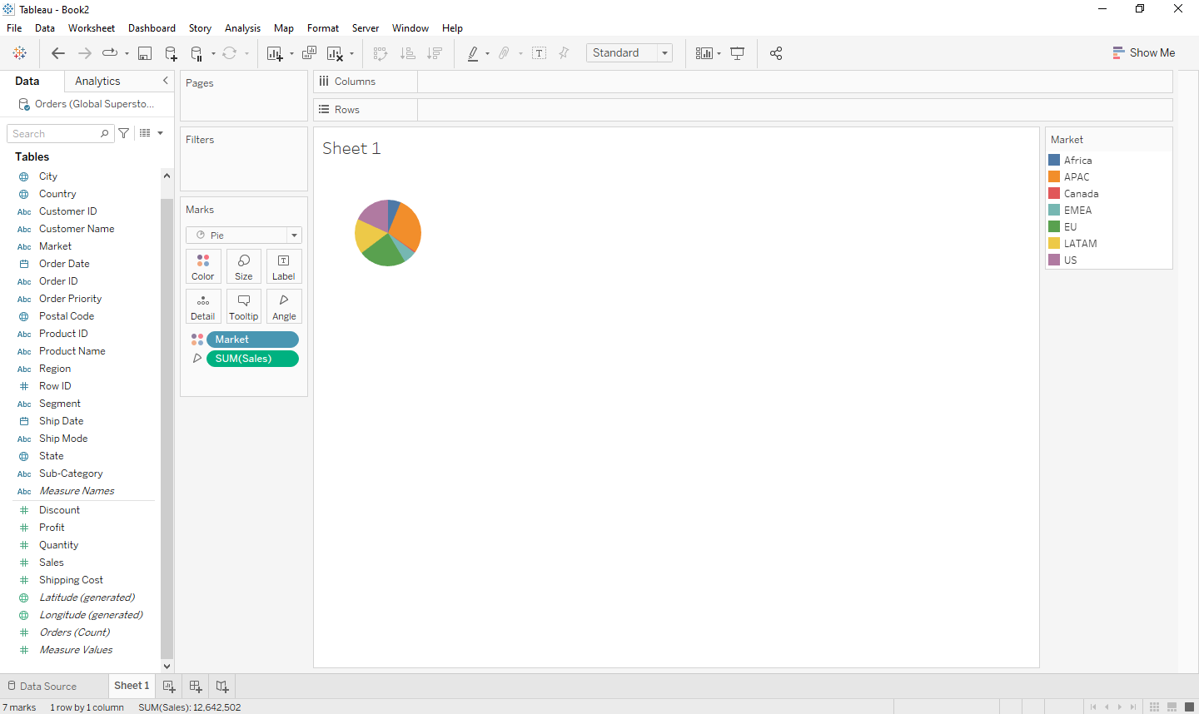
Market shown by colour, sales shown by angle.
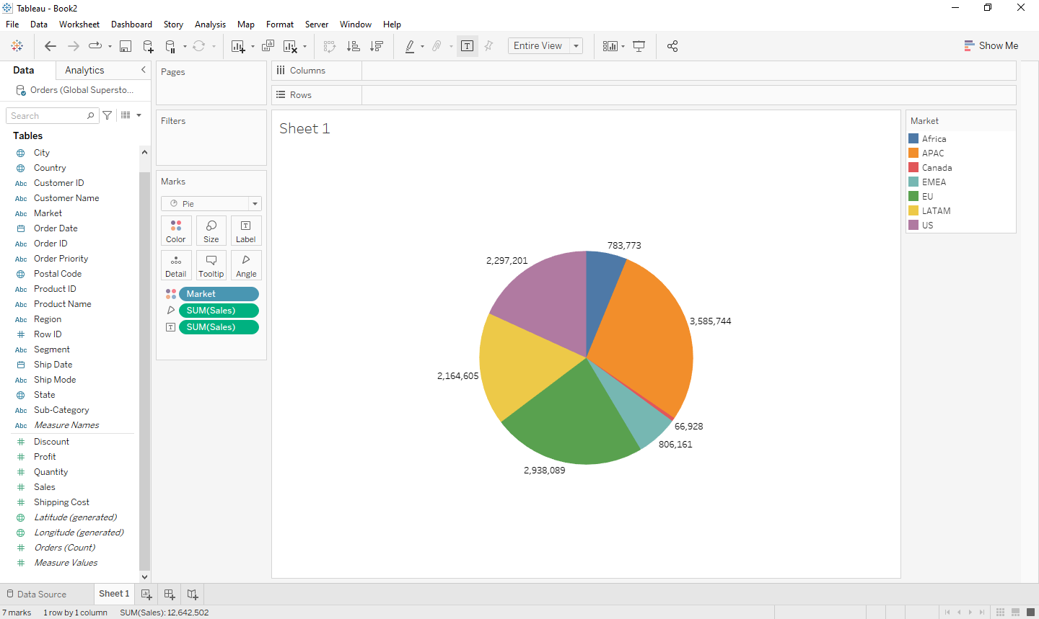
Changed to Entire View, labelled sales. APAC market has the highest sales, while Canada market has the lowest sales.
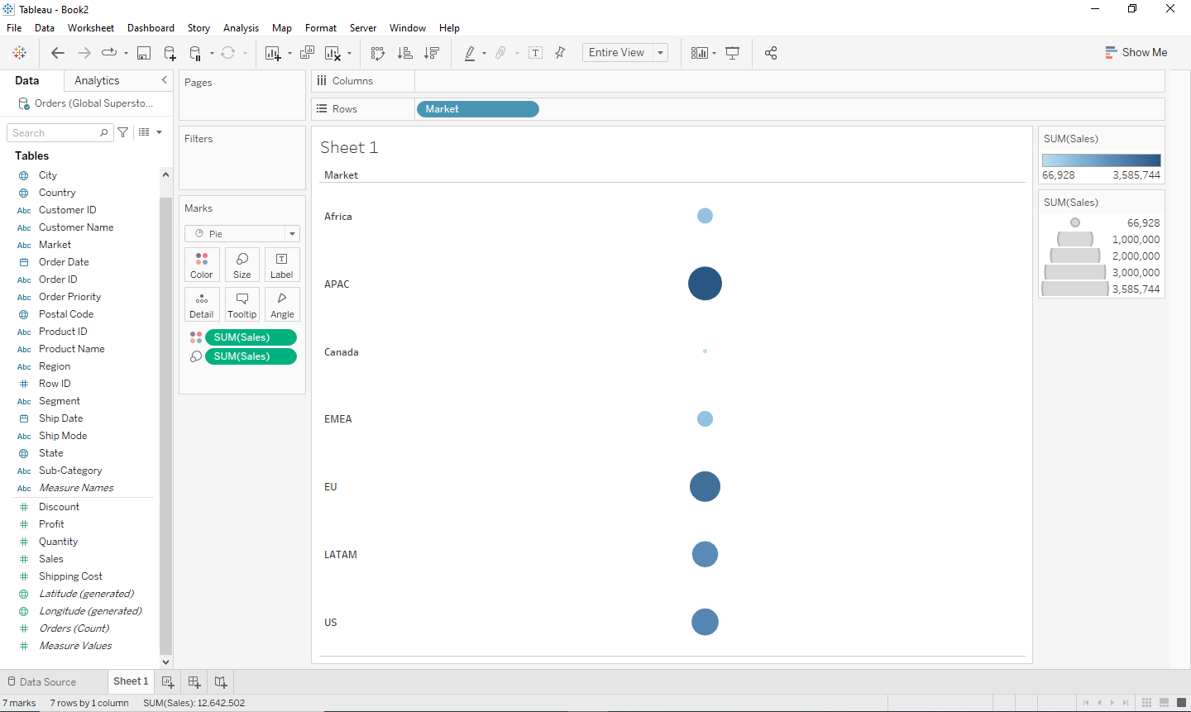
Coloured and sized according to sales.
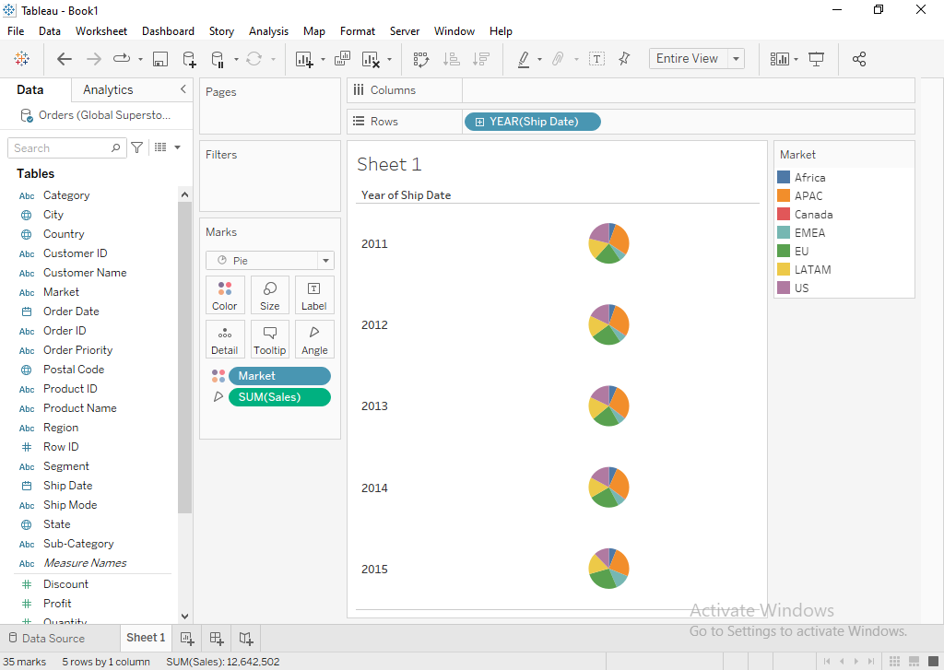
Represents sale of different markets by different colours according to year of ship date.

Scatter Plot
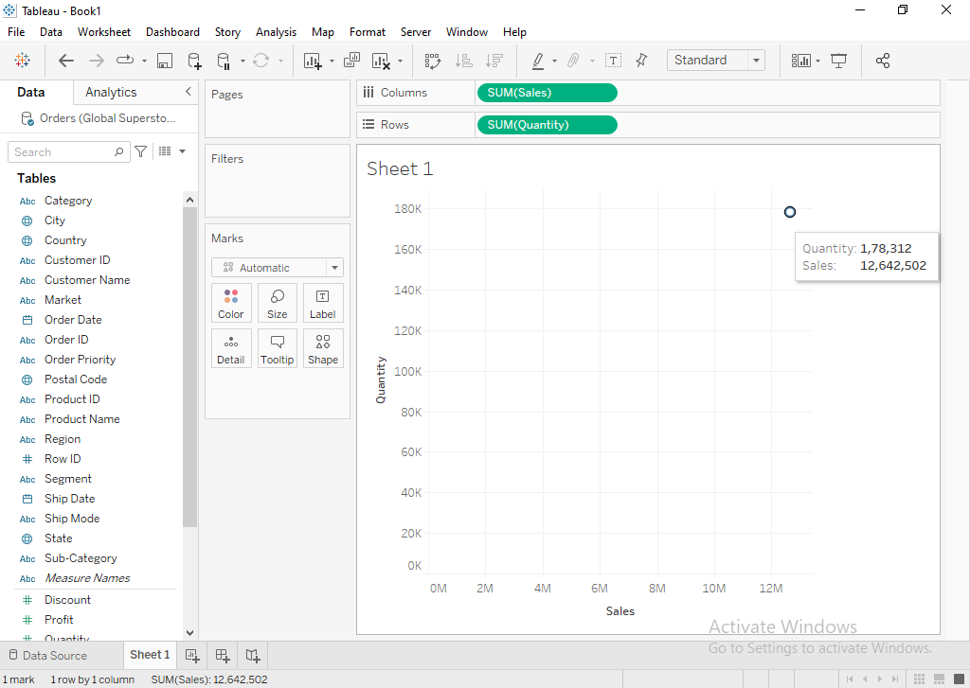
Sum of sales vs Sum of quantity.
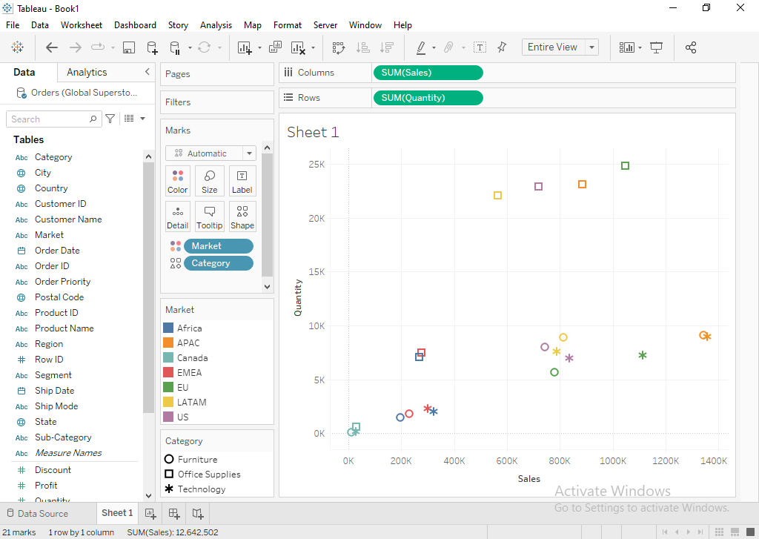
Sales vs Quantity showing different markets in different colours and different categories in different shapes.

Packed Bubble Chart
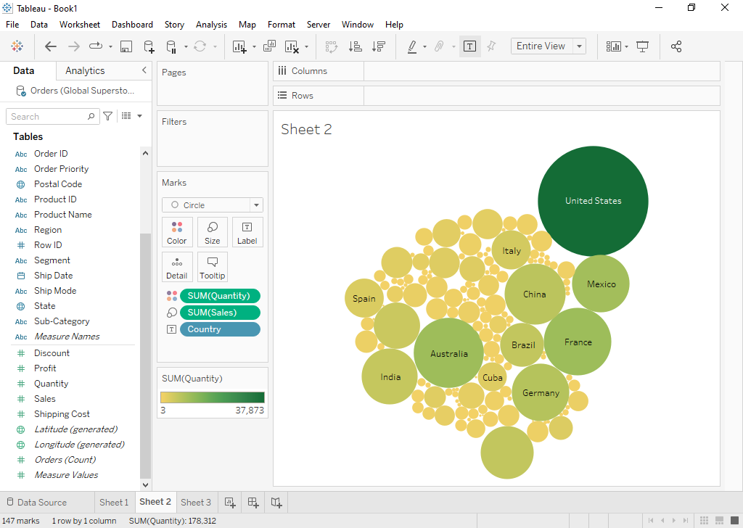
Represents Sales of different countries by the size of the bubble and quantity sold by the colour. United States has the highest number of sales along with the highest quantity sold.
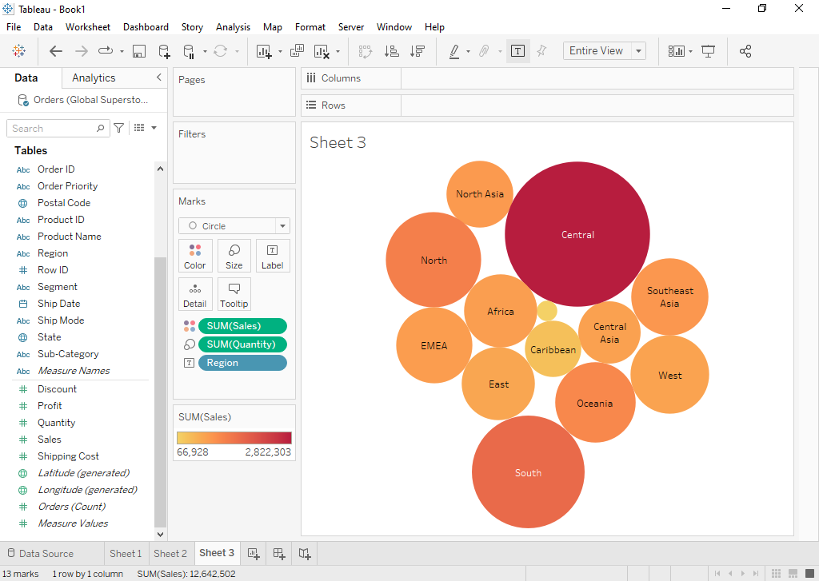
Represents Quantity sold by different regions by size of bubble and sales by each region by the colour. The Central region has the highest number of sales along with the highest quantity sold.

Donut Chart
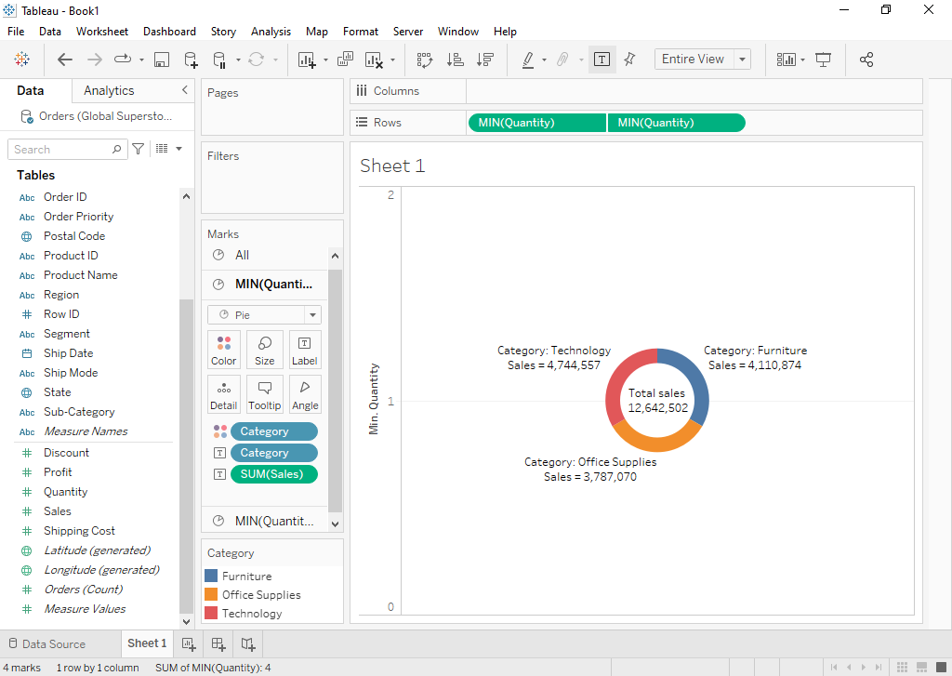
Represents Sales in different categories.
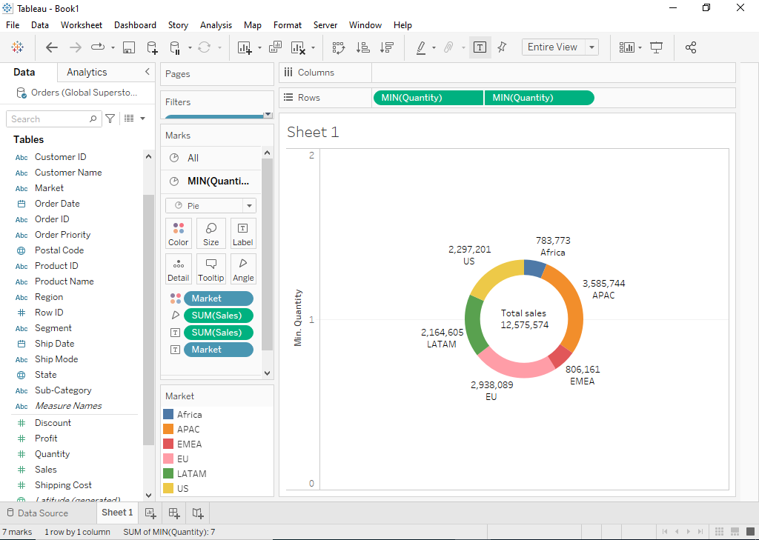
Represents Sales by different markets.

Conclusion (Students should write in their own words):

Tableau offers various charts for visualizing pre-processed data like Bar, Pie, Line, Scatter and Packed Bubble chart. These charts make it easier to interpret data as it removes the noise by highlighting trends and outliers.

Post Lab Question:

What are different data types supported in Tableau software?
The data types supported by Tableau are:
- String
- Integer
- Date
- Date and Time
- Boolean
- Geographic
- Cluster group or mixed

Which chart is most appropriate for visualizing your preprocessed dataset? Justify.
Different charts can be useful to analyze the data in different ways.
For the following dataset, a bar chart would be most appropriate as it allows us to compare the sales by market, category, sub-category or region with each other while showing even the slightest difference between similar selling products.
A donut chart could also be helpful to compare the sales from each category or sub-category as compared to the whole.

Date: 20/09/2022 Signature of faculty in-charge

